Project plan, Nabi Kabdylkakimov, CS-2311

My idea: GAME

This is a story that will have a linear route, depending on what action you choose. The story will have different characters and different stories, that will have different visual pictures that I provide and make by myself. It is a more like a creative work, where the big role plays my story that I will show to the player of the game.

The inspiration: 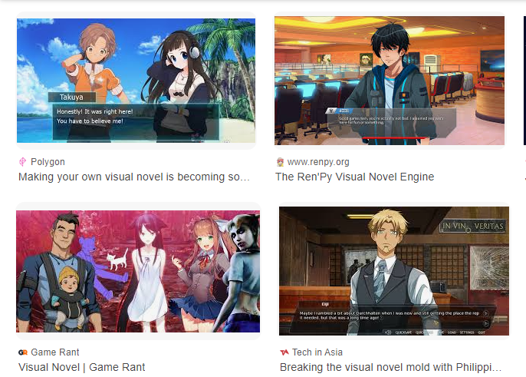

My responsibilities:

* Making an overall application that can launch a game
* Drawing pictures and making all of the visuals to the game
* Creating a story that will be interesting for the player
* Making a script in the game that knows what to do when doing the special action

The programs that I will use:

* PyGame
* 8bit Paint Maker
* IbisPaint
* Unity
* Python for Unity

What I want to achieve by making this project:

* Making a fully playable game
* To make it interesting for the internet community
* Creating a game that can be placed into the platforms like Steam or Google Play

Possible drawbacks of the project:

* It may be not popular and cannot be compared to the popular games in the novel game community